**Wribbenhall School**

**Safeguarding Policy**



Re-Written: Summer Term 2019

Date of Next review: Summer Term 2020

**To be read in conjunction with:**

Behaviour and Discipline Policy

Bullying and Harassment Policy

Child Protection Policy

Wribbenhall School Prospectus

**Approved by:**

**Proprietor:** Ellis Wells

17th August 2019

Wribbenhall School is committed to safeguarding and promoting the welfare of all children and young people both within the school environment and outside.

Wribbenhall School recognises its legal duty under s175/157 Education Act 2002 to work with other agencies in safeguarding children and protecting them from ‘significant harm’. These duties are de fined by:

* Working Together to Safeguard Children’ (2018)
* ‘Keeping children safe in education Statutory guidance for schools and colleges (2019)
* Worcestershire Safeguarding Children Partnership (WSCP)
* http://www.worcestershire.gov.uk/safeguardingchildren/

Our policy applies to all staff, governors, volunteers, students and any adult working in Wribbenhall School. There are five main elements to our policy:

Ensuring we practice safe recruitment in checking the suitability of staff and volunteers to work with children.



Raising awareness of child protection issues and equipping children with the skills needed to keep them safe.



Implementing procedures for identifying and reporting cases, or suspected cases, of abuse.



Supporting children who have been abused in accordance with their agreed child protection plan.



Establishing a safe environment in which children can learn and develop.



We recognise that because of the day to day contact with children and young people, staff are well placed to observe the outward signs of abuse, changes in children’s behaviour or their failure to develop. All staff need to be alert to the possibility of abuse occurring, aware of the procedures to be followed if they have concerns and have the confidence to follow these procedures. As part of this approach we are committed to using the ‘Child Protection Policy’ for Wribbenhall School.

Wribbenhall School will therefore:

* Establish and maintain an environment where children feel secure, are encouraged to talk, and are listened to.
* Ensure children and parents / carers know that there are adults in the school whom they can approach if they are worried.
* Include opportunities in the PSHE curriculum for children to develop the skills they need to recognise and stay safe from abuse including –
  + Emotional - excluding, tormenting, being unfriendly.
  + Physical - threats of or the direct use of violence, damage to property.
  + Sexual - sexually abusive comments, or unwanted physical contact or following someone around.
  + Homophobic - taunts, jokes or comments about an individual’s sexual
  + Orientation.
  + Ageist - taunts, jokes or comments about an individual’s age.
  + Racist - taunts, jokes or comments about an individual’s race.
  + Diabolist - taunts, jokes or comments about an individual’s disability.
  + Religion/beliefs - taunts, jokes or comments about an individual’s
  + religion/beliefs.
  + Verbal - name-calling, teasing, spreading rumours, sarcasm, shouting people down, swearing, coercion and making fun of people who seem different.
  + Cyber/electrical, threatening, abusive, offensive or unwanted mobile phone messages/calls/texts/emails or nasty comments posted on websites.
  + Sexting – sending private pictures, forwarding private pictures, demanding or coercing private pictures, written messages of a sexual nature.
  + Peer on Peer bullying - verbal, physical, emotional and any of the above.
* Display contact details/posters for Childline.

# Procedures

Wribbenhall School will ensure that all staff follow the procedures set out by the Worcestershire Safeguarding Children Board and take account of guidance issued by DfE to:

* Ensure we have designated senior persons for child protection who have received appropriate training and support for this role. The designated Child Protection Co-ordinator for Wribbenhall School is Mr Ellis Wells.
* Ensure we have a nominated governor responsible for child protection.
* Ensure every member of staff (including temporary and supply staff and volunteers) and governing body knows the name of the designated senior persons responsible for child protection and their role.
* Ensure all staff and volunteers understand their responsibilities in being alert to the signs of abuse and responsibility for referring any concerns to the designated senior persons responsible for child protection.
* Ensure that parents have an understanding of the responsibility placed on the staff at Wribbenhall School for child protection by setting out their obligations in the school prospectus.

* Ensure that parents are aware that this policy is available on request and make the policy available on the school website.
* Develop effective links with relevant agencies and co-operate as required with their enquiries regarding child protection matters including attendance at safeguarding meetings.
* Ensure that where there are concerns a Record of Concern Form is completed, even where there is no need to refer the matter immediately.
* Ensure all records are kept securely, and in locked locations.

Appendix 1 refers to what to do if you are concerned.

Appendix 2 is a copy of the Record of Concern Form which must be completed if a member of staff or volunteer has a concern about a child who attends Wribbenhall School.

Appendix 3 is a copy of the interagency referral form that must be completed when making a referral to Children’s Social Care. To ensure that the current copy is used this form should be accessed via the Worcestershire Safeguarding Board website at <http://www.worcestershire.gov.uk/safeguardingchildren/>

Appendix 4 provides a list of useful contact numbers.

# Safer Recruitment and Employment Practices

Wribbenhall School follows the Safer Recruitment and Managing Allegations Against People who work with children of WSCB Children Procedures. The Senior Designated Lead (Mr Ellis Wells) will deal with allegations made against staff. Any allegations against Mr Wells will be referred to the Chair of Governors

In addition to this Wribbenhall School has routine systems for continually monitoring the performance of the staff ensuring compliance with both child protection procedures and the code of good practice. All staff within Wribbenhall School will adhere to the Guidance for Safer Working Practice for Adults who work with Children and Young People (Nov 2015). All staff will have access to the counselling service provided by their Trade Union.

All allegations against people who work with children will be passed on to the Local Authority Designated Officer (LADO) in accordance with the Working Together to Safeguard Children (DfES 2015)

**Information Sharing, Confidentiality and Record Keeping**

Confidentiality is an issue which needs to be discussed and fully understood by all those working with children, particularly in the context of child protection. Every effort should be made to ensure that confidentiality is maintained for all concerned. Information should be handled and disseminated on a need to know basis.

Information will be stored in a secure place with restricted access to designated people and be maintained in a line with data protection laws.

**Curriculum**

Safeguarding and wider child safety issues will be addressed through the curriculum as appropriate, especially in PSHE, Computing, E-Safety, Citizenship and where age appropriate, Sex Education.

**Training and Development**

According to ‘Safeguarding Children and Safer Recruitment in Education’ 2006,

all staff who work with children will undertake training to equip them to carry out their responsibilities for child protection effectively. This will be kept up to date by refresher training at three yearly intervals for all staff. Temporary staff and volunteers will be made aware of the arrangements for child Protection and their responsibilities. The Designated Child Protection Co-ordinators (Mr Ellis Wells and Mrs Sally Wells) will receive refresher training as required to keep their knowledge up to date. The Senior Designated Lead (Mr Ellis Wells) responsible for recruitment must have completed the Safer Recruitment Training offered by WSCB.

**APPENDIX 1**

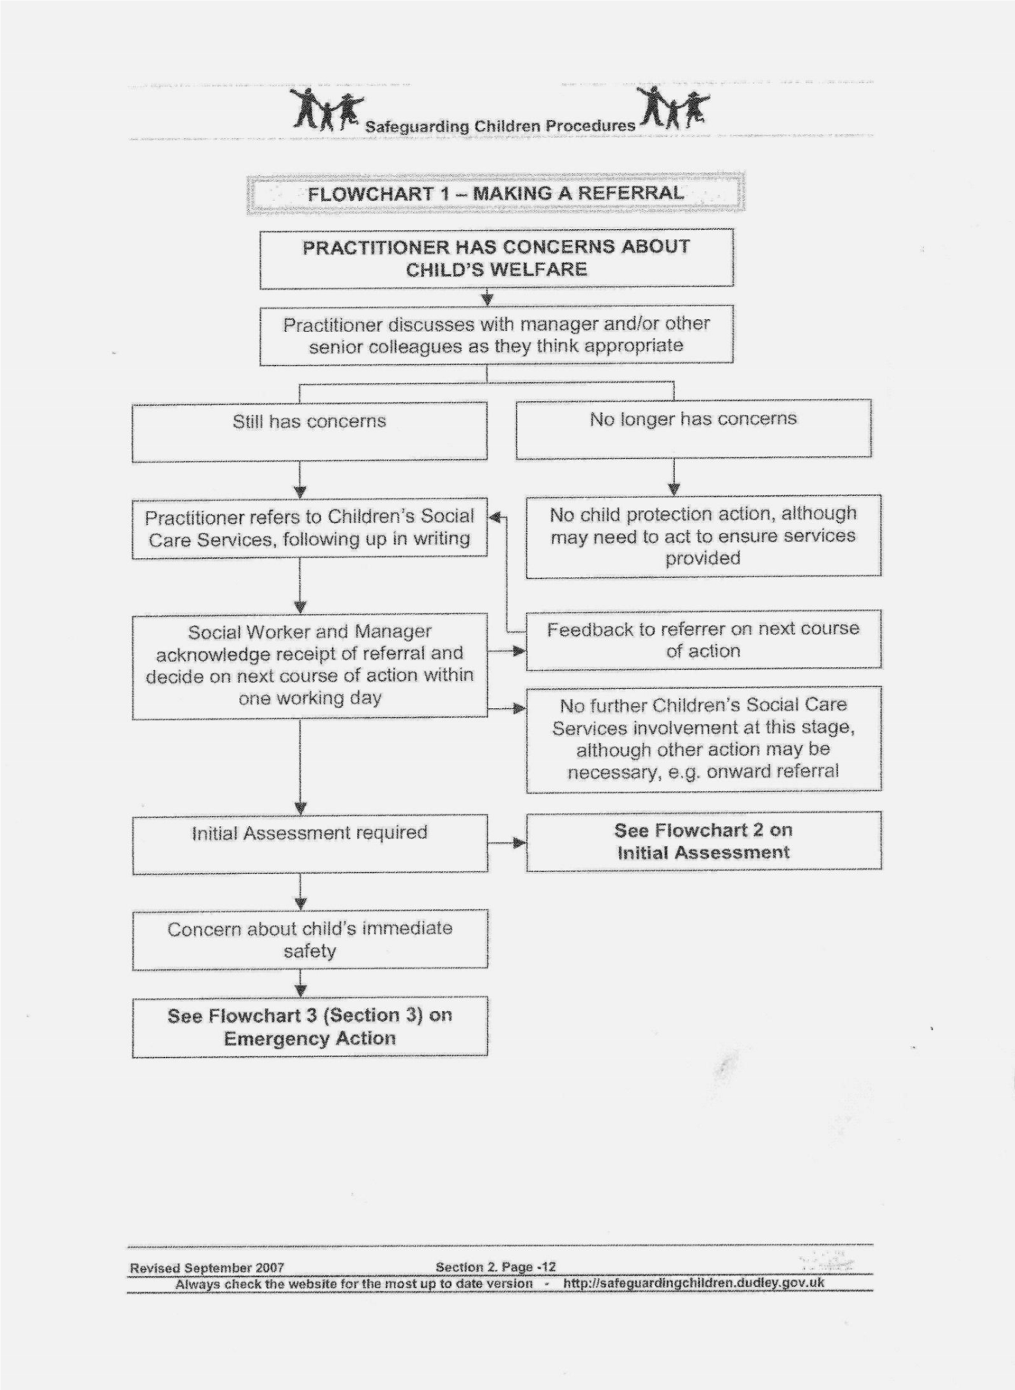

**APPENDIX 2**

**Wribbenhall School Record of Concern Form**

This form should be used to record all concerns that are raised about the safety and welfare of a child supported by Wribbenhall School. It should be completed by a member of staff and passed on to the designated Child Protection Co-ordinator to sign. If further concerns are raised at a later date, then a new form should be completed. An accumulation of forms should be an indicator that further action may be required to secure additional support for the child or family.

**INFORMATION/FRONT SHEET**

|  |  |  |  |  |  |  |  |  |  |  |  |  |
| --- | --- | --- | --- | --- | --- | --- | --- | --- | --- | --- | --- | --- |
| **Full Name:**  **Gender:** | | | **DOB:**  **Ethnicity:** | | | | **Class/Form:** | | | **Additional needs:** | | |
| **Home Address:** | | | | | | | **Telephone:**  **E mail:** | | | | | |
| **Status of file and dates:** | | | | | | | | | | | | |
| OPEN |  | |  | | |  | | |  | |  | |
| CLOSED |  | |  | | |  | | |  | |  | |
| TRANSFER |  | |  | | |  | | |  | |  | |
| **Any other child protection records held in school relating to this child or a child closely connected to him/her?**  **YES/NO WHO?** | | | | | | | | | | | | |
| **Members of household** | | | | | | | | | | | | |
| Name | Relationship to child | | | | DOB/Age | | | | Tel No | | |  |
|  |  | | | |  | | | |  | | |  |
|  |  | | | |  | | | |  | | |  |
|  |  | | | |  | | | |  | | |  |
|  |  | | | |  | | | |  | | |  |
|  |  | | | |  | | | |  | | |  |
| **Significant Others (relatives, carers, friends, child minders, etc.)** | | | | | | | | | | | | |
| Name | Relationship to child | | | | | | Address | | | | Tel No | |
|  |  | | | | | |  | | | |  | |
|  |  | | | | | |  | | | |  | |
|  |  | | | | | |  | | | |  | |
|  |  | | | | | |  | | | |  | |
|  |  | | | | | |  | | | |  | |
|  |  | | | | | |  | | | |  | |
|  |  | | | | | |  | | | |  | |
| **Other Agency Involvement** | | | | | | | | | | | | |
| Name of officer/person | | Role and Agency | | Status of Child i.e. CAF/CIN/CP/LAC | | | | Tel No | | | Date | |
|  | |  | |  | | | |  | | |  | |
|  | |  | |  | | | |  | | |  | |
|  | |  | |  | | | |  | | |  | |
|  | |  | |  | | | |  | | |  | |
|  | |  | |  | | | |  | | |  | |
|  | |  | |  | | | |  | | |  | |
|  | |  | |  | | | |  | | |  | |

**Chronology**

Sheet Number:

Complete for all incidents of concern including where a ‘logging the concern’ sheet has not been completed. If one has been completed, then add a note to this chronology to cross reference (significant information may also be added).

|  |  |  |  |
| --- | --- | --- | --- |
| Name: | | | |
| DOB: | | Class/Form: | |
| Date | Information/Details of concerns or contact | | Print Name and Signature |
|  |  | |  |

**Logging a concern about a child’s safety and welfare**

Part 1 (for use by any staff)

|  |  |
| --- | --- |
| **Pupil’s Name:** | **Date of Birth: Class:** |
| **Date and Time of Incident:** | **Date and Time (of writing):** |
| **Name:**  **…………………………………………………………….. ……………………………………………………………. Print Signature**  **Job Title:** | |
| **Record the following factually: What are you worried about? Who? What (if recording a verbal disclosure by a child use their words)? Where? When (date and time of incident)? Any witnesses?** | |
| **What is the pupil’s account/perspective?** | |
| **Professional opinion where relevant.** | |
| **Any other relevant information (distinguish between fact and opinion). Previous concerns etc.** | |
| **What needs to happen? Note actions, including names of anyone to whom your information was passed and when.** | |

**Check to make sure your report is clear to someone else reading it.**

**Please pass this form to your Designated Safeguarding Lead.**

Part 2 (for use by DSL)

|  |  |
| --- | --- |
| **Time and date information received, and from whom.** |  |
| **Any advice sought – if required (date, time, name, role, organisation and advice given).** |  |
| **Action taken (referral to children’s social care/monitoring advice given to appropriate staff/CAF etc.) with reasons.**  **Note time, date, names, who information shared with and when etc.** |  |
| **Parent’s informed? Y/N and reasons.** |  |
| **Outcome**  **Record names of individuals/agencies who have given information regarding outcome of any referral (if made).** |  |
| **Where can additional information regarding child/incident be found (e.g. pupil file, serious incident book)?** |  |
| **Should a concern/ confidential file be commenced if there is not already one? Why?** |  |
| **Signed** |  |
| **Printed Name** |  |

**Logging concerns/information shared by others external to the school (Pass to Designated Person)**

|  |  |  |
| --- | --- | --- |
| **Pupil’s Name:** | | **Date of Birth:**  **Class/form:** |
| **Date and Time of Incident:** | | **Date and Time of receipt of information:**  **Via letter / telephone etc.** |
| **Recipient (and role) of information:** | |  |
| **Name of caller/provider of information:** | |  |
| **Organisation/agency/role:** | |  |
| **Contact details (telephone number/address/e-mail)** | |  |
| **Relationship to the child/family:** | |  |
| **Information received:** | | |
|  | | |
| **Actions/Recommendations for the school:** | | |
|  | | |
| **Outcome:** | | |
|  | | |
| **Name:** |  | |
| **Signature:** |  | |
| **Date and time completed:** |  | |
| **Counter Signed by Designated Safeguarding Lead** |  | |
| **Name:** |  | |
| **Date and time:** |  | |

**Body Map Guidance for Schools**

Body Maps should be used to document and illustrate visible signs of harm and physical injuries.

Always use a black pen (never a pencil) and do not use correction fluid or any other eraser.

Do not remove clothing for the purpose of the examination unless the injury site is freely available because of treatment.

\***At no time should an individual teacher/member of staff or school take photographic evidence of any injuries or marks to a child’s person, the body map below should be used. Any concerns should be reported and recorded without delay to the appropriate safeguarding services, e.g. Social Care direct or child’s social worker if already an open case to social care.**

**When you notice an injury to a child, try to record the following information in respect of each mark identified e.g. red areas, swelling, bruising, cuts, lacerations and wounds, scalds and burns:**

1. Exact site of injury on the body, e.g. upper outer arm/left cheek.
2. Size of injury - in appropriate centimetres or inches.
3. Approximate shape of injury, e.g. round/square or straight line.
4. Colour of injury - if more than one colour, say so.
5. Is the skin broken?
6. Is there any swelling at the site of the injury, or elsewhere?
7. Is there a scab/any blistering/any bleeding?
8. Is the injury clean or is there grit/fluff etc.?
9. Is mobility restricted as a result of the injury?
10. Does the site of the injury feel hot?
11. Does the child feel hot?
12. Does the child feel pain?
13. Has the child’s body shape changed/are they holding themselves differently?

Importantly the date and time of the recording must be stated as well as the name and designation of the person making the record. Add any further comments as required.

**Ensure First Aid is provided where required and record**

A copy of the body map should be kept on the child’s concern/confidential file.

|  |
| --- |
| **BODYMAP** |

**(This must be completed at time of observation)**

|  |  |  |  |  |  |
| --- | --- | --- | --- | --- | --- |
| Name of Pupil: |  | | Date of Birth: | |  |
| Name of Staff: |  | | Job title: |  | |
| Date and time of observation: | |  | | | |

|  |  |
| --- | --- |
| BODY-1 | BODY-2 |

|  |  |  |  |  |
| --- | --- | --- | --- | --- |
| Name of pupil: |  | | Date and time of observation: |  |
| HEAD-1 | | HEAD-2 | | |
| **FRONT** | | **BACK** | | |
| HEAD-3 | | HEAD-4 | | |
| **RIGHT** | | **LEFT** | | |

|  |  |  |  |  |  |  |  |  |  |  |  |  |
| --- | --- | --- | --- | --- | --- | --- | --- | --- | --- | --- | --- | --- |
| Name of pupil: | |  | | | | | Date and time of observation: | | |  | | |
| HAND-1 | | | | | | HAND-2 | | | | | | | |
| **R** | | | | | | **L** | | | | | | | |
| **BACK** | | | | | | | | | | | | | |
| HAND-3 | | | | | | HAND-4 | | | | | | | |
|  | | | | | |  | | | | | | | |
|  | | | | | | | | | | | | | |
| Name of Pupil: | |  | | | | | Date and time of observation: | | |  | | |
| FOOT-1 | | | | | FOOT-2 | | | | | | | |
| **R** | **TOP** | | | **L** | **R** | | | **BOTTOM** | | | | **L** |
|  | | | | | | | | | | | | |
| FOOT-3 | | | | | FOOT-4 | | | | | | | |
| **R** | | | | | **L** | | | | | | | |
| **INNER** | | | | | | | | | | | | |
| FOOT-5 | | | | | FOOT-6 | | | | | | | |
| **R** | | | | | **L** | | | | | | | |
| **OUTER** | | | | | | | | | | | | |
| Printed Name, Signature and Job title of staff: | | |  | | | | | |  | |  | |

**Blank template**

|  |  |  |  |  |  |  |  |
| --- | --- | --- | --- | --- | --- | --- | --- |
| **Name of Child** | **DOB Class/form** | **Home Address** | **Parents/carer contact details** | **Name of Social worker and contact details** | **Other Agencies** | **Type of Plan**  **LAC**  **CP**  **CIN**  **CAF** | **Dates of: Conference,Reviews and Meetings** |
|  |  |  |  |  |  |  |  |
|  |  |  |  |  |  |  |  |
|  |  |  |  |  |  |  |  |
|  |  |  |  |  |  |  |  |
|  |  |  |  |  |  |  |  |
|  |  |  |  |  |  |  |  |
|  |  |  |  |  |  |  |  |
|  |  |  |  |  |  |  |  |
|  |  |  |  |  |  |  |  |
|  |  |  |  |  |  |  |  |
|  |  |  |  |  |  |  |  |
|  |  |  |  |  |  |  |  |
|  |  |  |  |  |  |  |  |
|  |  |  |  |  |  |  |  |
|  |  |  |  |  |  |  |  |
|  |  |  |  |  |  |  |  |
|  |  |  |  |  |  |  |  |
|  |  |  |  |  |  |  |  |
|  |  |  |  |  |  |  |  |

APPENDIX 3 Example referral form.

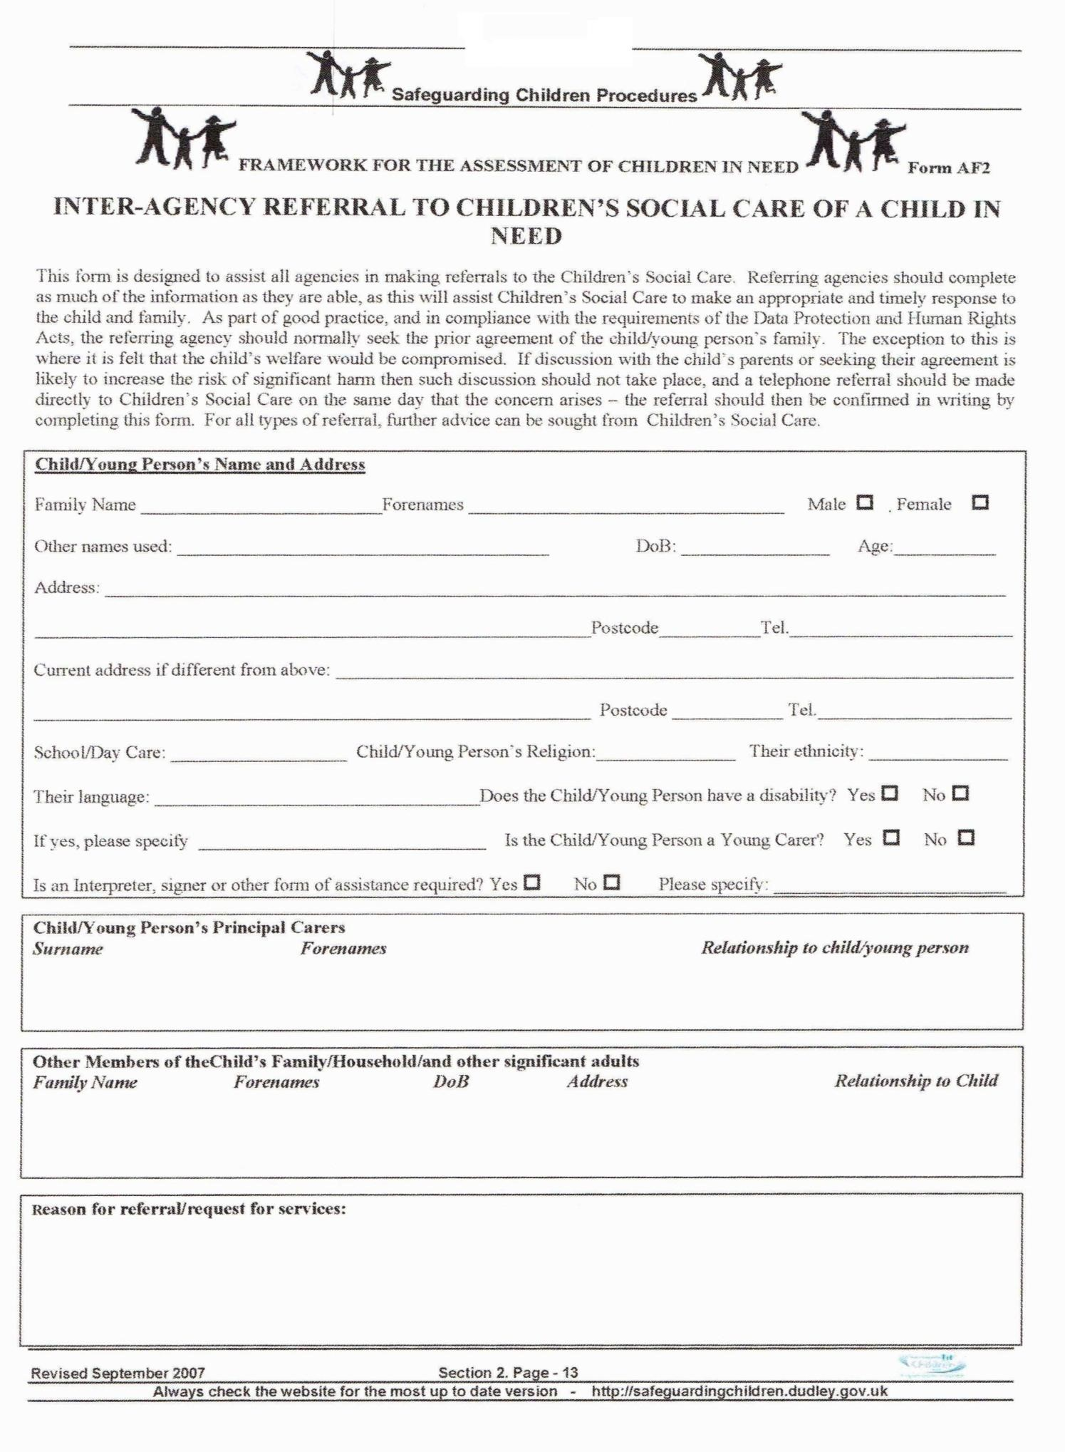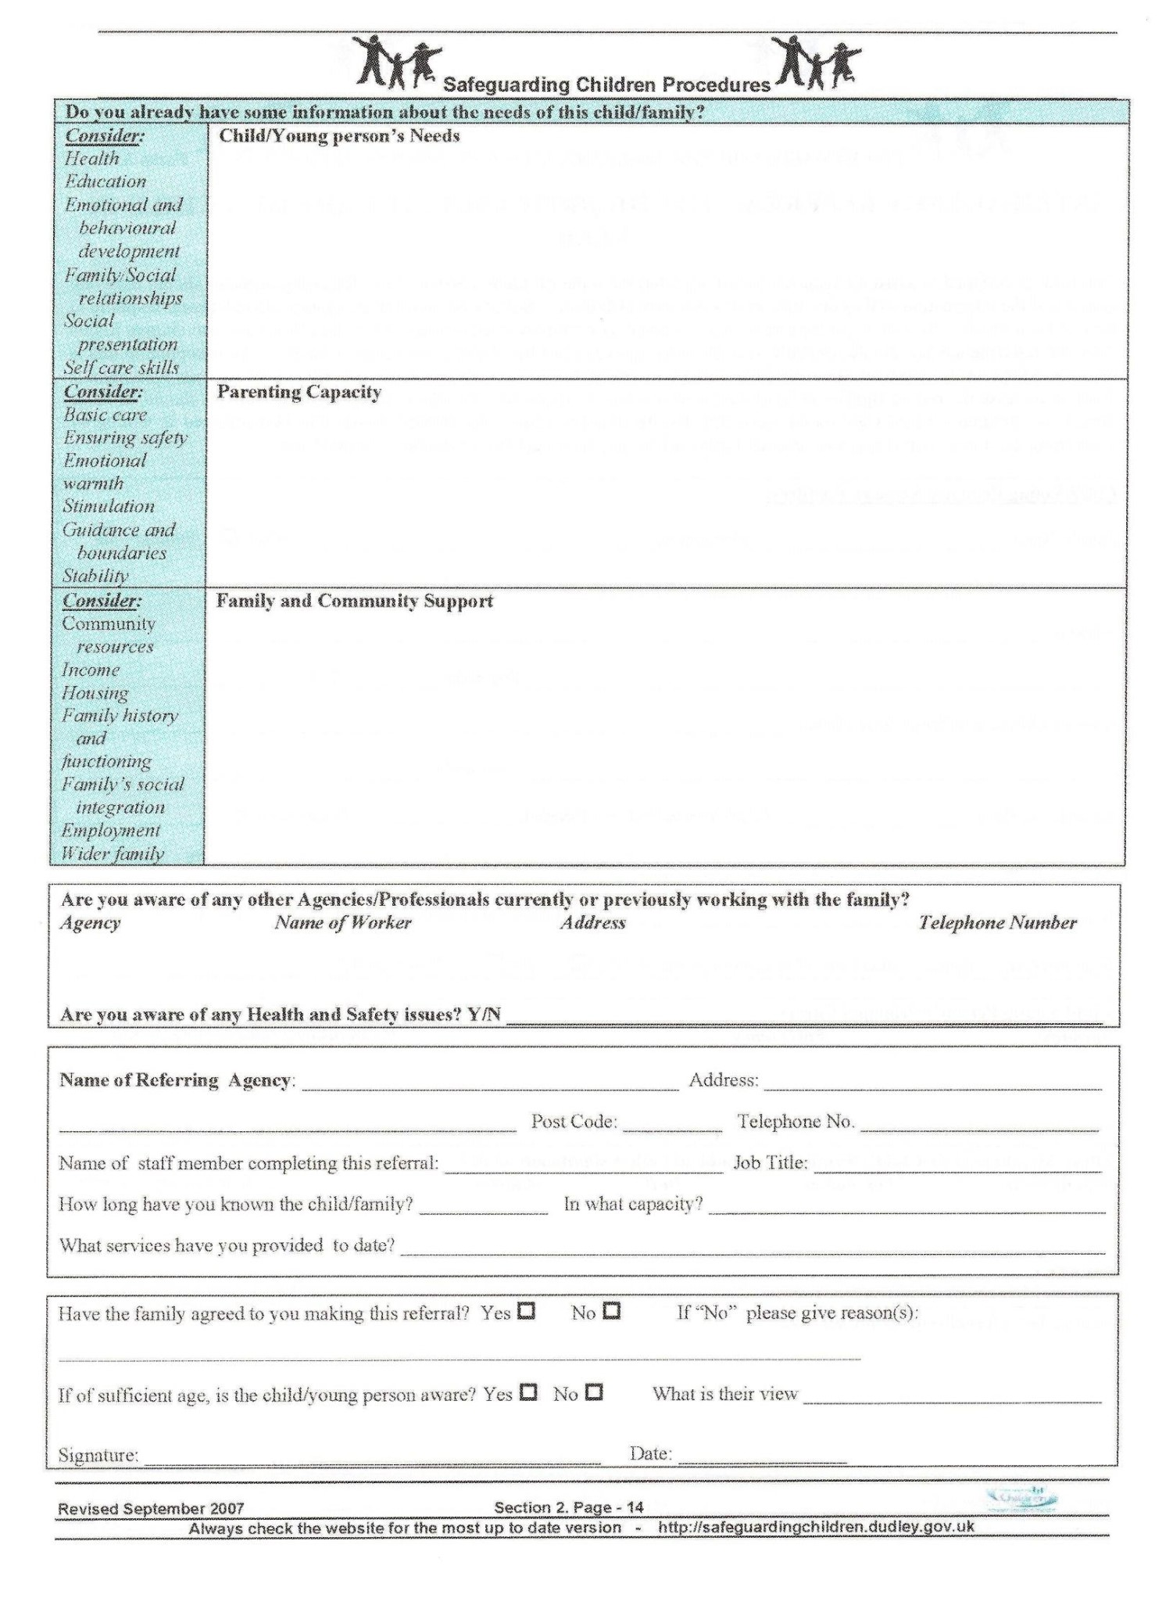

APPENDIX 4 Useful telephone numbers.

 

If you have reason to believe that a child or young person is at immediate risk from harm contact the Police on 999.

If you have any concerns about a particular child or young person and feel that they may be in need of protection or safeguarding, then please contact the Family Front Door on 01905 822666 from Monday to Friday 8.30am to 5.00pm.

For assistance out of office hours (5:00pm to 8:30 am weekdays and all day at weekends and bank holidays) please contact the Emergency Duty Team (EDT) on 01905 768020.